**HOW TO GET ONTO THE GENESIS PATIENT PORTAL (DS LOG IN account**)

1. Search for GENESIS PATIENT PORTAL
2. Click on the first result:

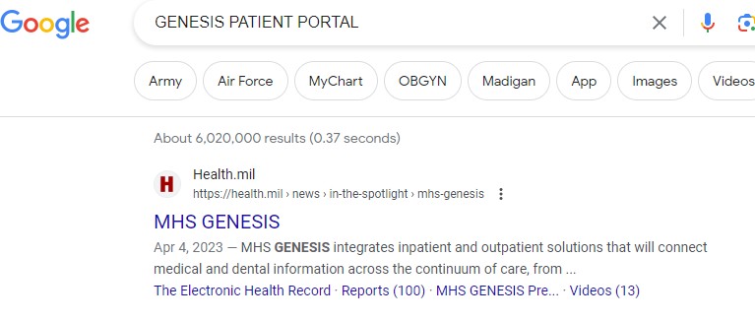

1. Click on small red banner:

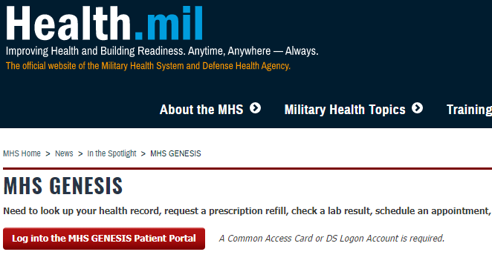

1. You are now at the “RED PAGE”

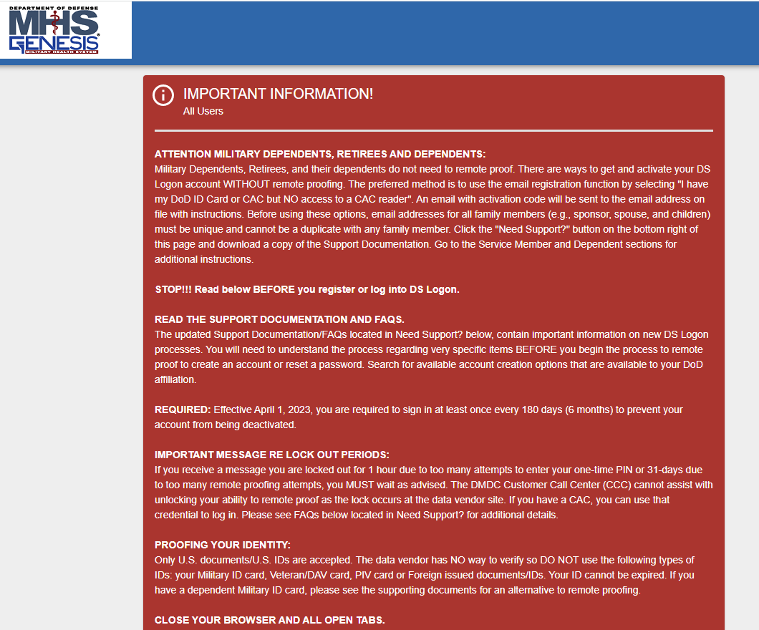

1. Scroll all the way to the bottom of the “RED PAGE”
2. 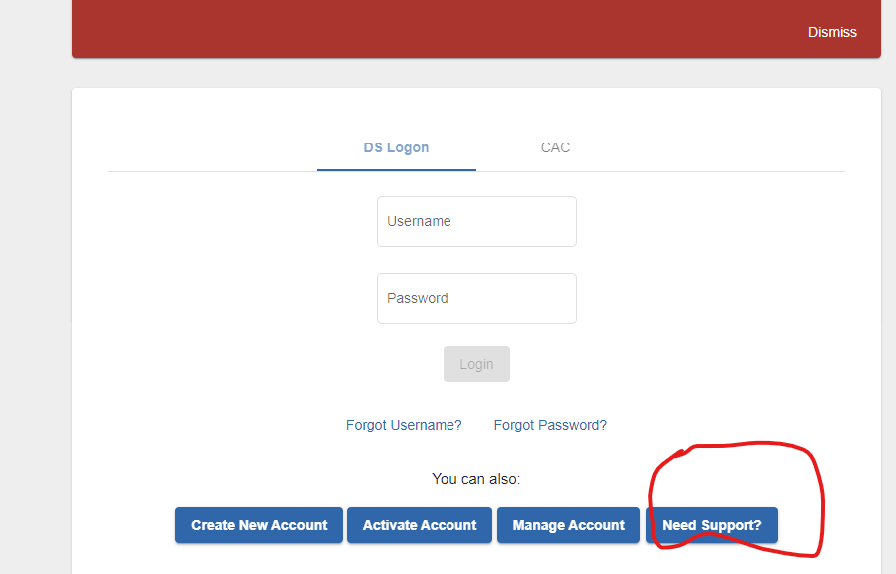

Click on “Need Support?”

A PDF will open – if you are not active duty, go to page 4 - 5 and Use the FIRST method listed. **You need to know is what your e mail address in DEERS is** - it takes minutes to get an account if you do it this way.

1. You will eventually need to click on “create new account” on the bottom LEFT side of the “RED PAGE”. This will walk you through what you need to do.