**Dermatomyositis**

* Immune mediated myopathy
  + Dermatomyositis
  + Polymyositis
  + Immune mediated necrotizing myopathy
  + Inclusion body myositis
* Skin findings (see below) + **symmetric proximal weakness** + muscle inflammation (as evidenced by CK, aldolase, AST elevations)
* Uncommon (annual incidence 1 per 100,000 persons)
* More common in women, any age

**Classic skin findings**

Heliotrope rash

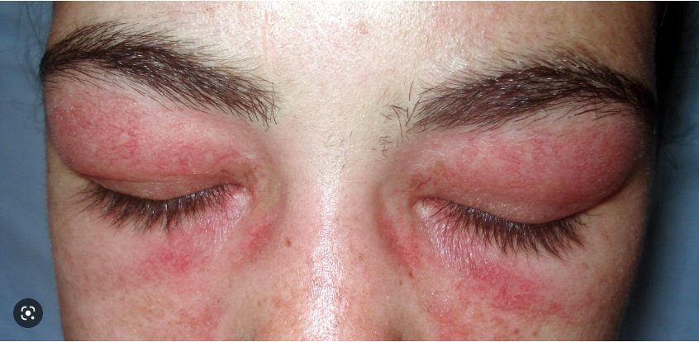

Holster sign (bilateral thigh rash)

Gottron’s papules (dorsal aspects of hands and feet) (A, D) and Gottron’s sign (B, C)

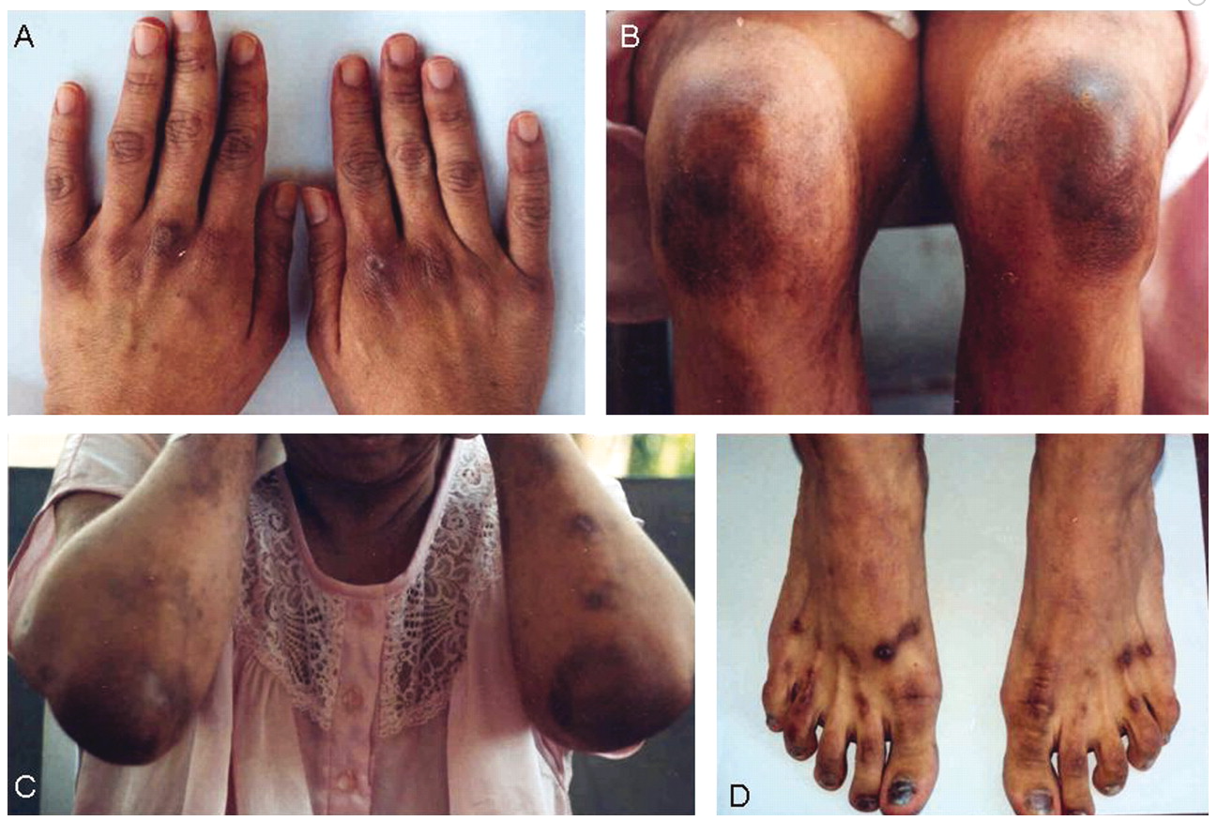

**Common extraarticular (non-dermatologic) manifestations**

ILD

Esophageal involvement (dysphagia = most common, aspiration also possible)

Cardiac involvement (myocarditis, conduction abnormalities 🡪 arrhythmia)

Challenge yourself – Create the below table comparing and contrasting the following commonly confused clinical entities. Focus on board relevance – ie, what are they going to focus on in the question stem?

|  |  |  |  |  |
| --- | --- | --- | --- | --- |
|  | Dermatomyositis | SLE | Polymyalgia rheumatica | Psoriatic arthritis |
| Disease script |  |  |  |  |
| Associated arthritis? Which joints? Symmetric/not? (if no/rare true arthritis, what joint related issue will come up?) |  |  |  |  |
| Associated skin findings (if any) |  |  |  |  |
| Other manifestations |  |  |  |  |