ACC/AHA 2017 HTN Guideline and 2021 update for Stage 1 HTN in low risk adults

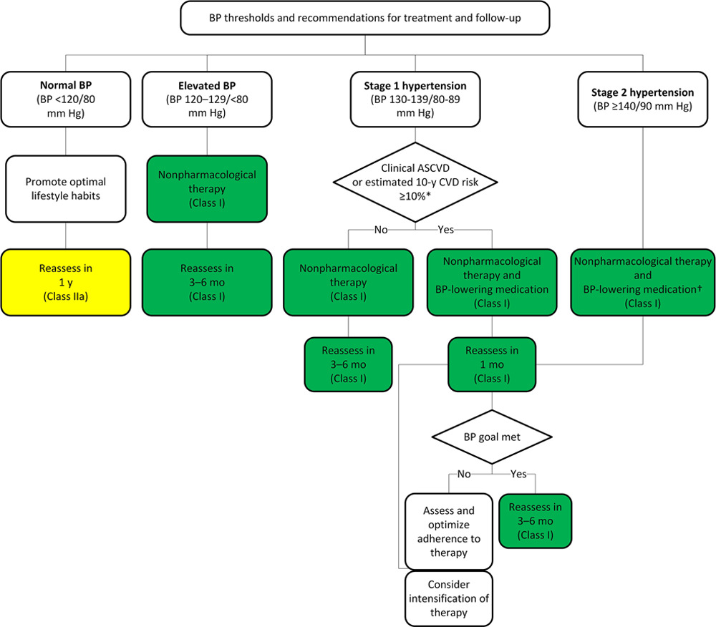

Use of BP-lowering medications is recommended for patients with:

- Clinical CVD (CHF, stroke, CAD) + average SBP ≥ 130 mmHg or average DBP ≥ 80 mmHg (secondary prevention)

- 10-year ASCVD risk ≥ 10% + average SBP ≥ 130 mmHg or average DBP ≥ 80 mmHg (primary prevention)

- 10-year ASCVD risk < 10% + average SBP ≥ 140 mmHg or average DBP ≥ 90 mmHg (primary prevention)

First line antihypertensives: Calcium Channel Blockers, ACEi/ARBs, thiazides

|  |  |  |  |  |  |
| --- | --- | --- | --- | --- | --- |
| **BP Category** | **SBP** |  | **DBP** | **Initial Treatment** | **F/u interval** |
| Normal | <120 | AND | <80 | lifestyle interventions | 1 year |
| Elevated | 120 - 129 | AND | <80 | lifestyle interventions | 3-6 months |
| Hypertension | | | | | |
| Stage 1 | 130-139 | OR | 80-89 | CVD or ASCVD > 10%  --> 1 antihypertensive | 1 month |
| ASCVD< 10% --> lifestyle | 3-6 months |
| Stage 2 | ≥140 | OR | ≥90 | 2 antihypertensives | 1 month |

First line antihypertensives: Calcium Channel Blockers, ACEi/ARBs, thiazides

|  |  |  |  |  |  |
| --- | --- | --- | --- | --- | --- |
| **BP Category** | **SBP** |  | **DBP** | **Initial Treatment** | F/u interval |
| Normal | <______ | AND | <______ |  |  |
| Elevated | ____ - ____ | AND | <______ |  |  |
| Hypertension | | | | | |
| Stage 1 | ____ - ____ | OR | ____ - ____ | CVD or ASCVD > 10%  --> ________________ |  |
| ASCVD < 10% --> _______________ |  |
| Stage 2 | ≥______ | OR | ≥______ |  |  |