**Asthma**

Characteristics:

Chronic inflammation

Variable airflow obstruction

* Fluctuations in symptoms and lung function over time
* Reversibility = Improvement in FEV1 or FVC by 200ml AND 12% with bronchodilator

Hyperresponsiveness

Clinical symptoms

Variety of triggers

Positive methacholine test = decrease in FEV1 by ≥20% at 400µg dose or less

High sensitivity (can essentially rule out asthma, but not exercise induced bronchoconstriction, with neg test), but low PPV (false positives with allergic rhinitis, bronchitis, CHF, COPD, cystic fibrosis)

SMART (Single Maintenance and Reliever Therapy) treatment is guideline recommended! = ICS + formoterol

* maintenance therapy with 1-2 puffs BID
* 1-2 puffs PRN for asthma symptoms
* Benefits:
  + Decreases asthma exacerbations requiring unscheduled visits
  + Decreases systemic corticosteroids
  + ?Improves asthma control and quality of life

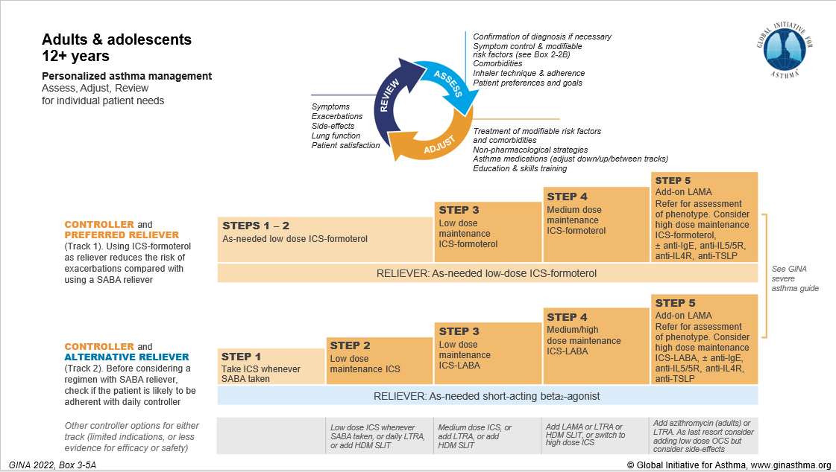

**STEPS 1-2** if symptoms < 4x/week. **Step 3** if sxs most days. **Step 4** if daily sxs, waking more than 1x/week - consider adding short steroid course

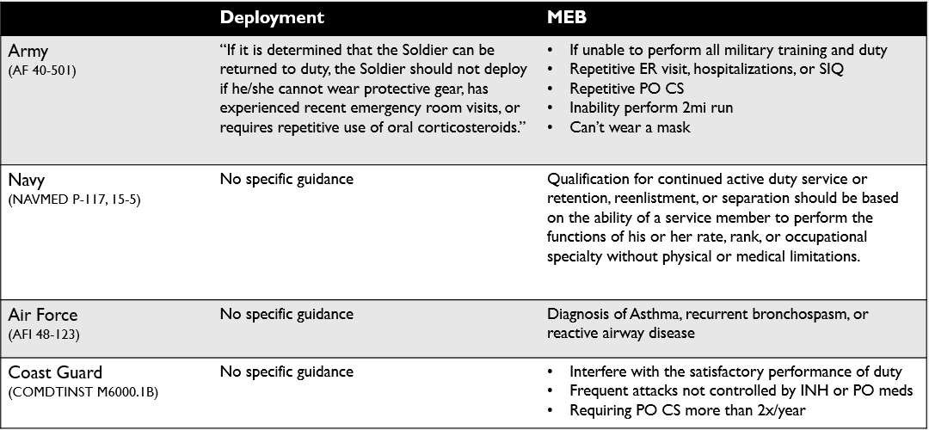

**Manual of the Medical Department (NAVMED P-117): Chapter 15: Medical Examinations: Special Duty (Navy)**

**Submarine duty:**

the following are causes for rejection:

1. History of bronchial asthma (reactive airway disease) after age 12 (waivers will not be considered).

**Diving duty:**

(4) Reactive airway disease or asthma, after age 12 (waiver request is not appropriate).