# Rheumatoid Arthritis – Plain Film Findings in Hands and Wrists

Hallmarks:

* Marginal Erosions (radial side of MCP Joints – 30% pts at Dx and 70% of pts 3yrs after Dx)
* Soft Tissue Swelling (don’t forget to evaluate soft tissues on your plain films!)
* Osteoporosis (typically “juxataarticular” initially)
* Join Space Narrowing (symmetric distribution)

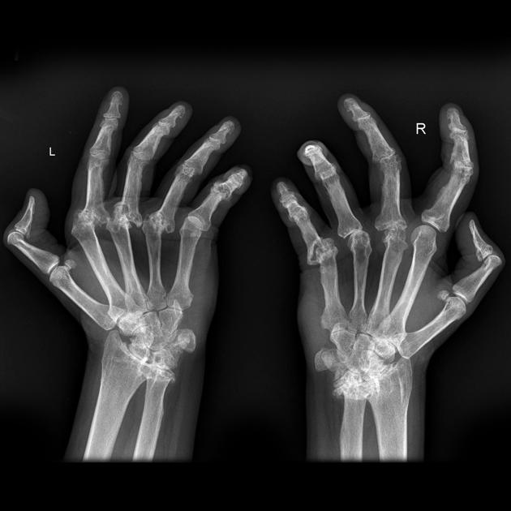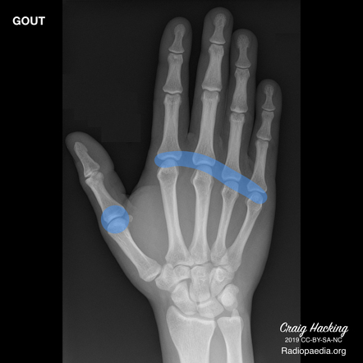Hands:

* PIPs
* MCPs
* Ulnar styloid
* Triquetrum
* SPARES THE DIPs

Late Findings:

* Subluxation with Ulnar Deviation
* Subchondral cyst formation
* Pencil-in-cup deformity
* Hichhiker’s thumb deformity
* Carpal instability