|  |  |  |  |  |
| --- | --- | --- | --- | --- |
| **MEDICATION** | **MOA** | **DOSING** | **AVOID** | **EFFECT** |
| **Warfarin** | Vitamin K antagonist | Variable | Pregnancy (X) | Annual RR of 68% for stroke (Arch Intern Med 1994;154:1449). |
| **Dabigatran** | Direct thrombin inhibitor | 150mg BID | CrCl <15 | 35% reduction in stroke compared to warfarin with no increase in major bleeding (RE-LY). |
| **Apixaban** | Direct factor Xa inhibitor | 5mg BID (2.5mg if Cr >1.5 AND age > 80 OR wt <60kg) | Severe hepatic impairment, CrCl <15 | Superior to warfarin or aspirin alone in preventing stroke and systemic embolism w/o increasing the risk of major bleeding or ICH (ARISTOTLE). |
| **Rivaroxaban** | Direct factor Xa inhibitor | 20mg QD (15mg if CrCl 15-50) | Severe hepatic impairment | Non-inferior to warfarin for prevention of stroke in non- valvular AF; no difference in major bleeding, ↓ICH, and fatal bleeding (ROCKET-AF). For cryptogenic stroke prevention, both non superior and associated w increased bleeding when compared to ASA (NEJM 2018;378;2191). Can be completely and quickly reversed w Idarucizumab. (NEJM 2015;373:511) |
| **Edoxaban** | Direct factor Xa inhibitor | 60mg QD | CrCl <30 | Noninferior to warfarin for prevention of stroke with lower rates of major bleeding and death (ENGAGE-AF). |

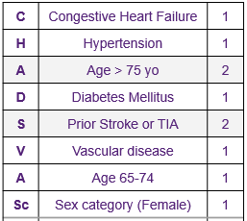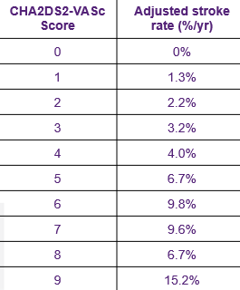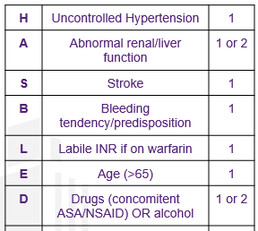

CHADS2VASc Score: Calculate stroke risk in patients with AFib

HAS-BLED: Assess 1 year risk of Major Bleeding

Major Bleeding = Intracranial, intraocular, RP bleed, Hgb decrease >2, Need for at least 2 units of blood, or death.

Valvular AFib = Associated with Moderate-Severe Mitral Stenosis OR Mechanical Valve

Valvular AFib 🡪 Requires Warfarin for Anti-Coagulation