**Menopausal Hormone Therapy (MHT)**

**Other Options for Vasomotor Symptoms:**

First Line = SSRIs/SNRIs:

* Venlafaxine
* Paroxetine
* Citalopram
* Escitalopram

Second Line Options:

* Gabapentin/Prgabalin
* Clonidine
* Oxybutinin

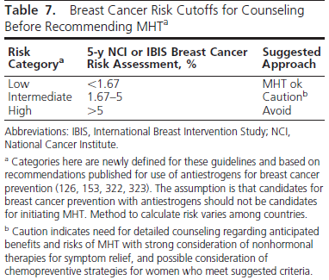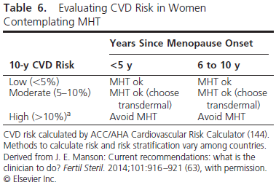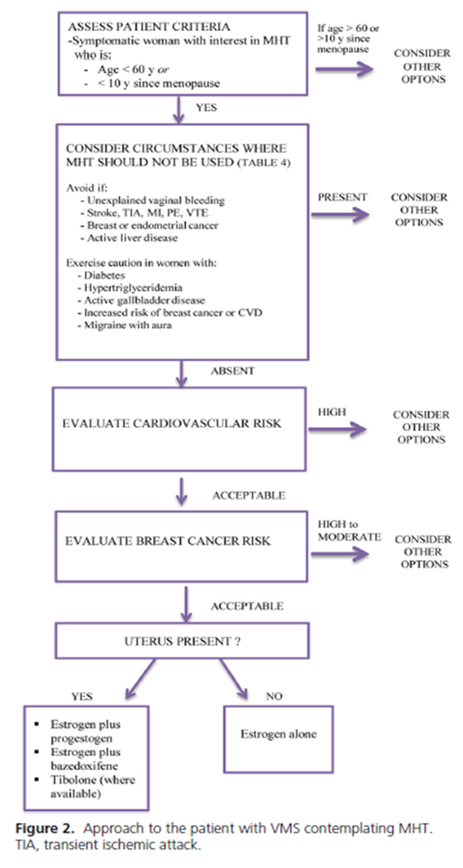

**Treatment Pearls:**

* Short term therapy is recommended: Not more than 5 years and Not beyond the age of 60. Consider tapering off therapy.
* While on therapy, recommended monitoring:
  + Routine mammograms and breast exams (breast cancer risk in WHI increased after 4th year)
  + For women with persistent unscheduled bleeding, evaluation for endometrial hyperplasia/cancer is needed
  + Follow up: initially 1-3 months after starting therapy then every 6-12 months
* Goal: to relieve menopausal symptoms
  + Vasomotor Symptoms
  + Mood lability/depression
  + Vaginal atrophy
  + Sleep disturbances (when related to hot flashes)
  + In some cases joint aches/pains
* NOT to be used for prevention of coronary heart disease and osteoporosiS