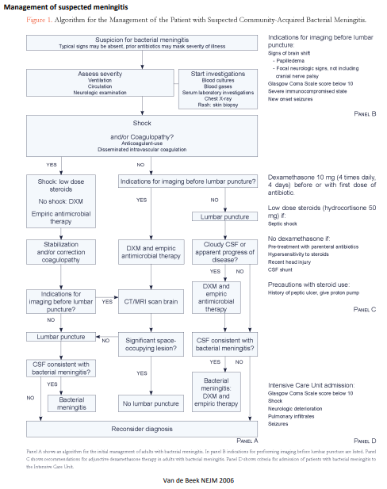

**Differential Diagnosis for CNS Infection**

|  |  |
| --- | --- |
| **Category** | **Etiology of Meningitis** |
| **Prion** | vCJD |
| **Virus** | HSV-1, HSV-2, Enterovirus (EV-71, Coxsackie, Echo), LCMV, HIV, mumps, measles, VZV, EBV, HHV6 (roseola), arboviruses: WNV, St. Louis, La Crosse, EEE, WEE, Zika |
| **Usual Bacteria** | N. meningitidis, S. pneumonia, H. influenza, S. aureus, GNRs, coag-Staph, Listeria, Brucella, Nocardia |
| **Atypical Bacteria** | Syphilis, Lyme, Tb |
| **Protozoa** | P. falciparum T. brucei T. cruzi Toxoplasma Amebae |
| **Fungus** | Cryptococcus, Histoplasma, many others |
| **Helminth** | angiostrongylus, Strongyloides, Schistosoma, Toxocara, T. solium |

