**Preoperative Assessment - includes 2014 AHA ACC guidelines**

ACCEPTED MANUSCRIPT

**Fleisher LA, et al.1**

**2014 ACC/AHA Perioperative Guideline** Colors correspond to the Classes of Recommendations in Table 1

**Figure 1.** Stepwise Approach to Perioperative Cardiac Assessment for CAD

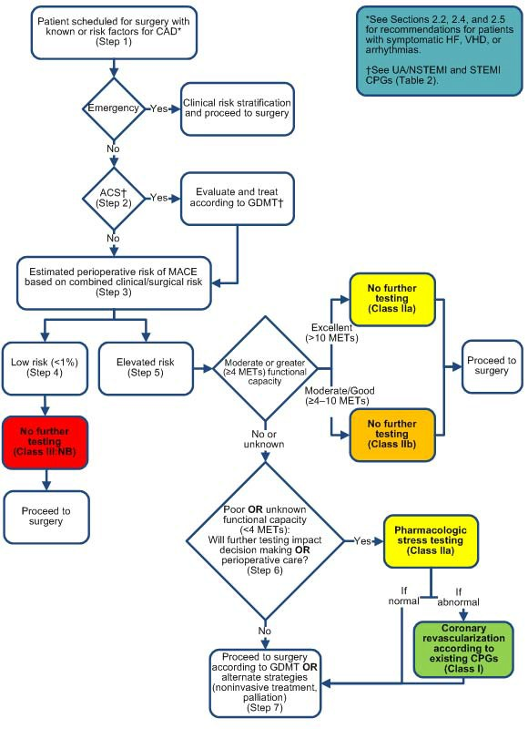

**Abbreviations:**

MACE = Major Cardiac Adverse Event

GDMT = Guideline Directed Medical Therapy

CPG = Clinical Practice Guideline

**ELEMENTS OF PRE-OP HISTORY AND PHYSICAL EXAM**

* Patient’s age, whether patient pregnant
* Exercise tolerance and ability to perform ADL
* Medication use
* Use of tobacco, alcohol, and illicit substances
* Overall health, including comorbid conditions, reaction to past surgeries, experience with anesthesia
* Risk factors for cardiac, pulmonary, infectious complications
* Physical: look for signs of undiagnosed or decompensated conditions
* ROS: chest discomfort, wheezing, cough, shortness of breath, edema, light-headedness, chest pain, exertional symptoms, and palpitations, as well as coronary revascularization, heart failure, cerebrovascular disease, hypertension, or valvular heart disease and lung disease.

**FUNCTIONAL ASSESSMENT**

* Duke Activity Score Index (DASI) performed better and may drive changes to the next guidelines update
* <https://www.mdcalc.com/duke-activity-status-index-dasi>
* The METS Trial compared subjective METS (metabolic equivalents) vs the DASI ([Duke Activity Index](https://www.mdcalc.com/duke-activity-status-index-dasi)) vs stress testing vs BNP. The DASI performed best for predicting postoperative events [[Wijeysundera Lancet 2018 – PMID 30070222](https://www.ncbi.nlm.nih.gov/pubmed/30070222)].

**METS for other common activities:**

**Walking:** The METS expenditure for walking can be anywhere from 2 METS (30 minute mile) to 5 METS (15 minute mile).

**Duke Activity Status Index**

Can you…

1. take care of yourself, that is, eating, dressing, bathing, or using the toilet? 2.75

2. walk indoors, such as around your house? 1.75

3. walk a block or 2 on level ground? 2.75

4. climb a flight of stairs or walk up a hill? 5.50

5. run a short distance? 8.00

6. do light work around the house like dusting or washing dishes? 2.70

7. do moderate work around the house like vacuuming, sweeping floors, or carrying in groceries? 3.50

8. do heavy work around the house like scrubbing floors or lifting or moving heavy furniture? 8.00

9. do yardwork like raking leaves, weeding, or pushing a power mower? 4.50

10. have sexual relations? 5.25

11. participate in moderate recreational activities like golf, bowling, dancing, doubles tennis, or

throwing a baseball or football? 6.00

12. participate in strenuous sports like swimming, singles tennis, football, basketball, or skiing? 7.50

**LABS**

Often times habit, an institution’s preoperative culture and medicolegal concerns lead to preoperative “routine” labs, xrays and ekgs

Rule of thumb for preoperative test and labs: Most tests aren’t indicated unless you would have ordered them in the absence of surgery.  See Table 2in [Cohn Annals Int Med 2016](http://annals.org/aim/article-abstract/2590906) for specific indications by test

However, the current literature suggests that there is little benefit from *indiscriminant* data gathering prior to *many* surgeries in healthy patients. Rather, false positives and their downstream impact (further testing and associated risks, delay procedure, patient anxiety, etc) can lead to adverse patient outcomes.

* Timing - When testing is indicated, many surgeons request data to be obtained within 30 days of the surgery; some suggest using tests within past 4 months if there has been no clinical change since labs obtained

When to get:

H/H:

* all patients 65+ undergoing major surgery
* younger patients undergoing surgery that in expected to result in significant blood loss, particularly if there is a history of anemia

PLT:

* when spinal or epidural anesthesia planned
* relevant PMHx (such as ITP, Myelotoxic medications, a history of bleeding diathesis, myeloproliferative disorder, or liver disease)

LEUKOCYTE COUNT

* Myelotoxic medications or symptoms suggesting infection or myeloproliferative disorder

CREATININE:

* patients 50+yo undergoing intermediate or high risk surgery
* in younger patients undergoing major surgery and/or suspected of having renal disease or with known CKD, hypertension, DM, cardiac disease, using medications known to impact renal function or likely to encounter perioperative hypotension or require perioperative nephrotoxic drugs

ELECTROLYTES:

* routine electrolytes NOT recommended unless the patient has a hx that increases the likelihood of abnormality

BLOOD GLUCOSE:

* routine screening NOT recommended for healthy patient
* consider in obese patients and an updated A1C in known diabetics

LIVER FUNCTION TESTS:

* a history of cirrhosis or an acute liver disease (an elevated MELD or Child Pugh classification could impact overall surgical risk estimation and advisably of surgery and should be documented if liver disease is part of a patient’s know history)

ALBUMIN

* Low values are a poor prognostic indicator. BUT, “correcting hypoalbuminemia” should not be pursued [[Kim. Am Surg. 2017 – PMID 29183523](https://www.ncbi.nlm.nih.gov/pubmed/29183523)]

HEMOSTASIS:

* not recommended unless the patient’s medical history, family history, or physical exam suggest presence of bleeding disorder or current heparin use
* if there is concern for a bleeding disorder, aPTT, PT, and platelet count reasonable to obtain

URINALYSIS

* Not recommended for most surgical procedures\* in asymptomatic patients as there is not clear evidence that untreated asymptomatic bacteriuria results in bacteremia, wound infections and worse patient outcomes
  + \*reasonable to obtain in genital-urologic procedures

PREGANCY TESTING

* -Because pregnancy can be a game changer for surgical risks, many recommended testing ALL reproductive-age women prior to surgery (some societies such as the American Society of Anesthesiologist recommend testing if a positive result would change management)

EKGs - *you must understand the surgery risk classification & individual RFs of your patient*

* General recommendations are NOT ordering an EKG for asymptomatic patients undergoing low-risk surgical procedures.
  + This is backed by 2014 ACC/AHA Guidelines on Perioperative Cardiovascular events
  + The 2014 European Society of Cardiology preoperative guidelines do not recommend obtaining EKGs in patients **WITHOUT** risk factors
* Who should get an ekg?
  + 2014 ACC/AHA guidelines recommend getting a resting 12-lead EKG for patients with
* Known CAD
* Significant arrhythmia
* Peripheral artery disease
* Cerebrovascular disease
* Other significant structural heart disease

EXCEPT patients undergoing a low-risk surgery (defined as risk of major adverse cardiac event <1%)

* A pre-op EKG may also be reasonable for asymptomatic patients undergoing a surgery with elevated (>=1%) risk of major adverse cardiac event
* The 2009 AHA Scientific Advisory on Cardiovascular Evaluation and Management of Severely Obese Patients Undergoing Surgery suggests obtaining 12-lead EKG in:
* Severely obese patients (BMI >= 40kg/m2) with at least 1 RF for CAD (DM, HTN, HLD, smoking)

CHEST RADIOGRAPHS & PFTS

* ACP recommends CXR for patients with cardiopulmonary disease and those who are 50+yo undergoing abdominal aortic aneurysm surgery or upper abdominal/thoracic surgery
* The AHA recommends a PA/Lateral for patients with severe obesity (BMI>=40mg/m2)

**ESTIMATING PERIOPERATIVE RISK OF MAJOR ADVERSE CARDIAC EVENTS – which tool to use?**

* It is reasonable to use any of the three surgical calculators (RCRI, MICA, or ACS-NSQIP) as part of your perioperative medicine evaluation [[Cohn Am J Cardiol 2018 – PMID 29126584](https://www.ncbi.nlm.nih.gov/pubmed/29126584)]
* use [ACS NSQIP surgical risk calculator](https://riskcalculator.facs.org/RiskCalculator/) for more medically complex patients. It predicts length of stay, the need for rehab, and risk of non-cardiac post-op complications, and more
* [The RCRI](https://www.mdcalc.com/revised-cardiac-risk-index-pre-operative-risk) is the oldest and has been externally validated for predicting major adverse cardiac events. It may overestimate the risk for low risk surgical procedures and underestimate the risk for major vascular surgeries  [[Cohn Annals Int Med 2016 – PMID 27919097](https://www.ncbi.nlm.nih.gov/pubmed/27919097)]
* “myocardial infarction or cardiac arrest” calculator aka [MICA (aka Gupta)](https://www.mdcalc.com/gupta-perioperative-risk-myocardial-infarction-cardiac-arrest-mica) may perform best at identifying high risk patients [[Cohn Am J Cardiol 2018 – PMID 29126584](https://www.ncbi.nlm.nih.gov/pubmed/29126584)]

**Revised Cardiac Risk Index:**

- RCRI – six factors: creat>2; insulin requiring DM; Surgery: supra-inguinal vascular, intraperitoneal, or intrathoracic; compensated or prior heart failure; history of cerebrovascular disease; history of ischemic heart disease

- A patient with 0 or 1 predictor(s) of risk has a low risk of MACE, 0.4% TO 0.9%. A patient with ≥2 predictors of risk has

elevated risk.

- Outcome reported: Risk of major adverse cardiac events.

- Online: <http://www.mdcalc.com/revised-cardiac-risk-index-for-pre-operative-risk/>

**ACS (NSQIP) Surgical Risk Calculator:**

- Allows you to specify exact procedure

- Helpful for high risk pts who are undergoing low risk procedures (eg. Patient on dialysis with FEV1 of 0.7 who is undergoing cataract surgery)

- Helpful for patients with significant non-cardiac morbidities, for example, severe COPD

- Outcomes reported: Risk of major adverse cardiac events (called “cardiac complication” – this is the same as the risk of MACE generated by RCRI ) and multiple others, ranging from wound infection to death – see the web site.

- Access it by searching for “NSQIP risk calculator” or http://riskcalculator.facs.org/RiskCalculator/index.jsp

**WHEN TO CONSIDER PREOPERATIVE CARDIAC STRESS TESTING?**

* In general, preoperative stress testing is NOT recommended for asymptomatic patients [[Cohn Annals Int Med 2016](http://annals.org/aim/article-abstract/2590906)]. It’s warranted ONLY if needed to work up a patient’s symptoms (i.e. you would have ordered it even absent a plan to pursue surgery).
* Indications for noninvasive cardiac testing are generally the same for patients undergoing surgery as for those who are not. Patients with worrisome symptoms should be evaluated for cardiac ischemia, usually with cardiac stress testing, but evaluation is usually unnecessary in patients with chronic stable angina. The previous version of these ACC/AHA guidelines classified patients in the highest-risk group when they had an active cardiac condition, such as unstable angina, decompensated heart failure, uncontrolled arrhythmias, severe valvular disease, or recent percutaneous coronary intervention. The latest guidelines combine clinical and procedural risk using one of three tools to estimate whether a patient is at low (<1%) or elevated (≥1%) risk for postoperative cardiac complications. The tools recommended by the guidelines include the Revised Cardiac Risk Index, the American College of Surgeons National Surgical Quality Improvement Program risk calculator, or the myocardial infarction (MI) or cardiac arrest (MICA) tool www.surgicalriskcalculator.com/miorcardiac arrest). Patients who are deemed to be at low risk (<1% risk of cardiac complications) may proceed to surgery without preoperative cardiac testing. Likewise, patients with elevated risk (>1% risk of cardiac complications) who have good exercise capacity also do not need further preoperative cardiac testing before a low- or intermediate-risk procedure. Patients who are at elevated cardiac risk who have poor functional status may be considered for noninvasive testing before surgery if the results are likely to change management.
* While **preoperative coronary revascularization** does not seem to prevent postoperative cardiac events or death [[Cohn Annals Int Med 2016](http://annals.org/aim/article-abstract/2590906)**], preoperative stress testing** may inform perioperative medical and surgical management for select patients.
* preoperative revascularization was not shown to improve mortality in patients with stable angina ([The CARP trial – NEJM 2004l](https://www.nejm.org/doi/full/10.1056/NEJMoa041905)). Similarly, in patients with positive dobutamine stress echocardiography, revascularization did not lower the rate of postoperative MI or death at 30 days or 1 year ([The DECREASE V trial – PMID: 17466225](https://www.ncbi.nlm.nih.gov/pubmed/17466225)).  —[Cohn SL. In the Clinic: Preoperative Evaluation for Noncardiac Surgery. Annals Int Med. Dec 2016. doi:10.7326/AITC201612060](http://annals.org/aim/article-abstract/2590906)….**BUT, stress testing may help inform risk/benefit discussions, and influence medical therapy, type of anesthesia, surgical setting, and other nuanced perioperative decisions!!!!**

#### WHAT ABOUT POSTOPERATIVE MYOCARDIAL INJURY (MINS)?

* About 65 percent of patients with **myocardial injury after noncardiac surgery** (MINS) are clinically asymptomatic [[Duceppe CJC 2017](https://www.onlinecjc.ca/article/S0828-282X(16)30980-1/pdf)]. Cardiac troponin testing increases the sensitivity to detect MINS. Patients with MINS after noncardiac surgery have a poor prognosis [[Duceppe CJC 2017](https://www.onlinecjc.ca/article/S0828-282X(16)30980-1/pdf)]. MINS is an independent predictor of 30-day and 1-year mortality [[Botto et al Anesthesiology 2014 PMID 24534856](https://www.ncbi.nlm.nih.gov/pubmed/24534856); [MANAGE Trial page ClinicalTrials.gov](https://clinicaltrials.gov/ct2/show/NCT01661101)].
* In the [MANAGE Trial](https://doi.org/10.1016/S0140-6736(18)30832-8), MINS was defined by elevated cardiac troponins with either 1) symptoms of ischemia 2) ischemic EKG changes 3) wall motion abnormalities on echocardiogram OR elevated troponin after surgery with no alternative explanation (e.g., pulmonary embolism, sepsis) for myocardial injury. [[Devereaux Lancet 2018](https://doi.org/10.1016/S0140-6736(18)30832-8)]
* The MANAGE trial tested dabigatran versus placebo for MINS. It found a slight decrease in the composite outcome of “major vascular events” without a significant increase in major bleeding [[Devereaux Lancet 2018](https://doi.org/10.1016/S0140-6736(18)30832-8)].

#### CANADIAN PERIOPERATIVE MEDICINE GUIDELINES ([2016 CCS Perioperative Guidelines](https://www.ncbi.nlm.nih.gov/pubmed/27865641))

* If the RCRI is ≥1, the patient’s age is ≥65, or they are between 45-64 with significant cardiac disease\*, the next step is to measure the patient’s NT-ProBNP or BNP if this is available at your institution.
* If the NT-ProBNP is ≥300 ng/L or BNP is ≥92 ng/L, then there should be an EKG ordered in the PACU and troponins should be measured daily for 48-72 hours.
* If, after risk stratification, the NT-ProBNP is <300 ng/L or BNP <92 ng/L, no routine postoperative cardiac monitoring is warranted.
* If the institution does not have these assays available, then all patients should be monitored with an EKG in the PACU and troponin measurements daily for 48-72 hours if they meet one of the following: RCRI ≥1, age ≥65, or age 45-64 with the aforementioned cardiac disease.\*
* The data supporting the use of NT-ProBNP/BNP comes from a large 2014 meta-analysis of 18 studies with a total of 2,477 patients ([Rodseth 2014](https://www.ncbi.nlm.nih.gov/pubmed/24076282" \t "_blank)). This study, which was in agreement with multiple previous meta-analyses, noted that for those patients with a pre-operative NT-ProBNP of <300 ng/l or BNP <92 ng/l, the rate of 30-day postoperative non-fatal MI or Death was 4.9% (3.9%-61%), and was 21.8% (19.0%-24.8%) in those with pre-operative NT-ProBNP is ≥300 ng/L or BNP is ≥92 ng/L.  
    
  \*Known history of coronary artery disease, cerebral vascular disease, peripheral artery disease, congestive heart failure, severe PHTN or a severe obstructive intracardiac abnormality (e.g. severe aortic stenosis, severe mitral stenosis, or severe hypertrophic obstructive cardiomyopathy).
* Currently ACC/AHA does not recommend following the above. Unclear if this changes outcomes. Maybe best used to better access risk pre-operative at this time.

**SPECIAL CONSIDERATIONS FOR PATIENTS WITH CARDIOVASCULAR DISEASE**

**Heart failure** - is a predictor of increased perioperative risk. Risk is greater with decompensated versus compensated HF, systolic (reduced ejection fraction) versus diastolic (preserved ejection fraction) HF, and symptomatic versus asymptomatic HF (39). Elective surgery should be delayed in a patient with decompensated HF to allow for medical optimization.

**Valve disease** - If initial clinical evaluation yields suspicion of significant valve disease, obtain a transthoracic echocardiogram. If the valve disease is severe, consider referral to cardiology. Patients with symptomatic severe aortic stenosis (angina, dyspnea, syncope) undergoing noncardiac surgery are usually best treated by preoperative aortic valve replacement. If valvular disease is asymptomatic, however, most patients can undergo noncardiac surgery with appropriate monitoring and medical therapy.

**HTN** - Although severe hypertension, with systolic pressure >180 and diastolic pressure >110, has been considered a risk factor for adverse perioperative outcomes and is the reason that many surgical procedures are cancelled, there is little evidence to support this practice.

* Pre-existing HTN is the most common cause for postponing surgery
* HTN is a known risk factor for CV events
  + Case-control study of 76 patients who died of CV cause w/in 30d of surgery
  + Pre-op dx of HTN was 4x more likely in the cases than controls
* Induction of anesthesia 🡪 sympathetic activation w/BP inc 20-30 mmHg & HR inc 15-20 bpm in normotensive pts; untreated HTN pts may have increases of BP up to 90 mmHg & HR 40 bpm
* Intraop BP lability (high or low) more common in pts w/ HTN and puts pts at risk for myocardial ischemia

**BP Cut off??**

* Level of risk is dependent on the severity of HTN, but no def cut off
* Data on impact of poorly controlled HTN comes from older uncontrolled studies done p/t the existence of current, more effective, meds for HTN
* ACC/AHA guidelines list uncontrolled HTN as a “minor “ risk factor
* Possible cut off of DBP 110mmHg
* SBP cut off unclear

**Who needs a preoperative echocardiogram**? TTE for patients who meet criteria of 2014 ACC/AHA guidelines, “unexplained dyspnea, heart failure with a change in condition, or suspected valve disease (as well as those with known valvular disease who are overdue for imaging) –[2014 ACC/AHA Periop Guidelines JACC 2014](http://www.onlinejacc.org/content/64/22/e77)

**SPECIAL CONSIDERATIONS FOR PATIENTS WITH PULMONARY DISEASE**

* **Pulmonary complications** may be **more common and costly** than cardiac complications [[Qaseem Ann Int Med 2006](http://annals.org/aim/fullarticle/722250) ; [Sabate Curr Opin Anaesthesiol. 2014](https://www.ncbi.nlm.nih.gov/pubmed/24419159)].
* An elevated serum bicarbonate or low resting oxygen saturation should raise the level of concern.
* Factors that increase the risk for pulmonary complications include type of surgery, older age, chronic obstructive pulmonary disease (COPD), smoking, uncontrolled asthma, poor exercise capacity, low albumin, renal insufficiency, obstructive sleep apnea (OSA), and pulmonary hypertension. When surgery is near the diaphragm, the type of surgery influences pulmonary complications, with thoracic, upper abdominal, and aortic procedures carrying the highest risk. General anesthesia also increases risk.
* To minimize postoperative pulmonary complication risk
  + Cease smoking at least 4 to 8 weeks before surgery
  + Conduct lung expansion maneuvers or CPAP
  + Reduce airflow obstruction and treat respiratory infection
  + Preoperative chest PT and inspiratory muscle training
  + Screen patients for OSA (STOP-BANG questionnaire)
  + Use local instead of general anesthesia
  + hospital instead of ambulatory surgical center
  + 23 hour observation instead of same day discharge
  + sleep in recliner instead of flat in bed
  + minimize post-op opioids!!!
  + ensure family member supervision night of surgery.
  + Spirometry: only for those having lung resection, active wheezing, unexplained impaired exercise tolerance
* To minimize postoperative pulmonary complications, during the procedure these patients should receive certain precautionary measures, such as pulse oximetry or carbon dioxide monitoring, minimal narcotics, and elevation of the head of the bed.

**COPD/Asthma**

* Pre-Op Goal: assess risk for perioperative bronchospasm and delayed extubation, reintubation.
* During H&P think about…
* Disease control - frequency of SABA use
* Disease history/severity – disease-related intubation and systemic steroid use
* History of respiratory operative complications
* Infection screen
* If disease is uncontrolled: Optimize prior to elective surgery
* If disease control is unclear: Consider CXR, spirometry +/- DLCO
* Perioperatively, continue optimized outpatient Rx + early ambulation + lung expansion techniques (e.g. incentive spirometry q1-2hr while awake, deep breathing exercises) + avoid benzos + consider positive airway pressure

**Obstructive Sleep Apnea**

* Pre-Op Goal: identify and mitigate risk for perioperative hypoxemia (OR 7.9), respiratory failure, unplanned reintubation, ICU transfer (OR 4.43), etc
* Screening for OSA
  + “Screen everyone!” (Society of Anesthesia and Sleep Medicine)
    - Psst…. Data lacking but this makes sense
  + Especially screen patients with comorbidities associated with OSA
    - HTN, T2DM, obesity, HF, stroke
  + Validated screening questionnaires have higher sensitivity than specificity (therefore, most helpful when they are negative or low score)
    - STOP-BANG (best validated)
* Mgmt of OSA
* Well controlled disease 🡪 instruct patients to bring their device on day of surgery
* Suspected or uncontrolled OSA
  + Urgent surgery 🡪 proceed to surgery
  + Elective surgery
    - Is there evidence of impaired gas exchange? (hypoventilation syndrome, severe pulm HTN, resting hypoxemia in absence of other cardiopulmonary disease)
      * If impaired gas exchange 🡪 defer surgery
      * If no impaired gas exchange
        + High risk procedures 🡪 defer surgery
        + Low risk procedures 🡪 proceed to surgery

For surgeries usually performed in the outpatient setting, consider whether ambulatory surgery is appropriate

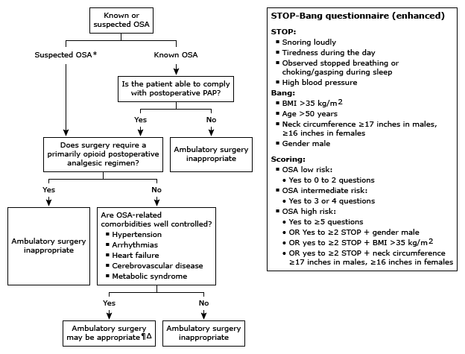

**SPECIAL CONSIDERATIONS FOR PAIN MANAGEMENT -** Counseling patients about **perioperative pain** including expected pain level and plan for pain management may improve perceived pain scores and decrease the needs for narcotic pain medications [[Altman JAMA Otolaryngol 2017 – PMC5824296](https://www.ncbi.nlm.nih.gov/pmc/articles/PMC5824296/)]

**SPECIAL CONSIDERATIONS FOR PATEINTS WITH DIABETES**

Patients with diabetes face a higher risk for perioperative morbidity and mortality, with complications including hyperglycemia, hypoglycemia, diabetic ketoacidosis (DKA), postoperative infections, cardiac complications, and postoperative stroke. Although elevated glucose and HbA1C have been associated with increased risk of complications, it is unclear whether or not there is any absolute cutoff above which elective surgery should be postponed. Early-morning surgery is generally preferred to minimize disruption in glycemic control. Generally, patients on an insulin pump or insulin glargine do not need to change their basal rate or usual dose. Exceptions include when the dose might be reduced for patients who are on a bowel prep (clear liquids with reduced calories), have had previous hypoglycemic episodes, or have their surgery scheduled late in the day. On the morning of surgery the dose of NPH is reduced to half or two-thirds, and short-acting insulin and oral hypoglycemics are withheld. Patients with type 1 diabetes or insulin-deficient type 2 diabetes are at risk for DKA, and require insulin even when their glucose levels are in the normal range.

* Perform A1c, if not done in the last 3 months.
* There is some suggestion that elevated A1C levels predict a higher rate of postoperative adverse events, including infections, myocardial infarction, and mortality.
* Baseline glucose levels can also help to stratify risk for postoperative wound infections.

**SPECIAL CONSIDERATIONS FOR PATEINTS WITH RHEUMATOLOGIC DISEASE**

Patients with rheumatoid arthritis and cervical joint disease are potentially at risk for perioperative neurologic problems from neck manipulation during intubation. Precautions should be taken before intubation for other patients who have significant peripheral joint erosions, long-standing symptomatic disease, or long-term corticosteroid therapy or disease modifying anti-rheumatic drugs.

* Precautions to avoid perioperative neurologic problems
  + Cervical collar
  + Fiberoptic intubation
  + Preoperative cervical spine films to assess C1–2 stability
  + Careful neck positioning
* Rheumatologic treatments may increase infection risk

**MEDICATIONS**

Preoperative medication adjustment: These are GENERAL guidelines – subject to individual’s clinical circumstance

**ANTIHYPERTENSIVE AGENTS**

* Diuretics - hold the day of surgery
* Beta Blockers – continue perioperatively if already on them; if not already on them….DO NOT start day before surgery
  + Intermediate/high risk myocardial ischemia on risk strat tests noted, may be reasonable to start perioperatively
  + 3+ RCRI factor, may be reasonable to start
  + In patients with a compelling long-term indication for beta-blocker therapy but no other RCRI risk factors, initiating beta blockers in the perioperative setting as an approach to reduce perioperative risk is of uncertain benefit
  + In patients in whom beta-blocker therapy is initiated, it may be reasonable to begin perioperative beta blockers long enough in advance to assess safety and tolerability, preferably more than 1 day before surgery
* Calcium channel blockers – continue perioperatively; assoc with reduced death/MI with diltizam;
  + Dihydropyridines and verapamil did not decrease the incidence of myocardial ischemia, although verapamil decreased the incidence of supraventricular tachycardia
* ACEI/ARBS – Controversial; ok to stop or continue. Need to weigh the risk of intraoperative hypertension vs hypotension and AKI

**GLUCOSE LOWERING AGENTS**

* be aware of patient’s oral intake status – for example, people who are undergoing bowel prep may have decreased oral intake for the entire day before surgery
* Take the patient’s overall diabetes control into consideration when making medication recommendations. For example, someone with an A1C of 8.5 who is only taking metformin will likely need coverage with insulin when an inpatient in contrast to a person with A1C of 6.
* Hold sulfonylureas, pio/rosiglitazone, acarbose on the day of surgery
* Hold metformin, GLP1s, and gliptans (DPP-4 inhibitors) the day before surgery
* Hold SGLT2 inhibitors (e.g canagliflozin, empagliflozin) two days before surgery
* Long acting insulin: decrease dose to 50-80% the night prior to surgery. For inpatient control of blood sugars, please recommend using a weight-based basal dose with scheduled pre meal boluses as well as correction doses of insulin – see below
* Basal/ Bolus dosing of insulin

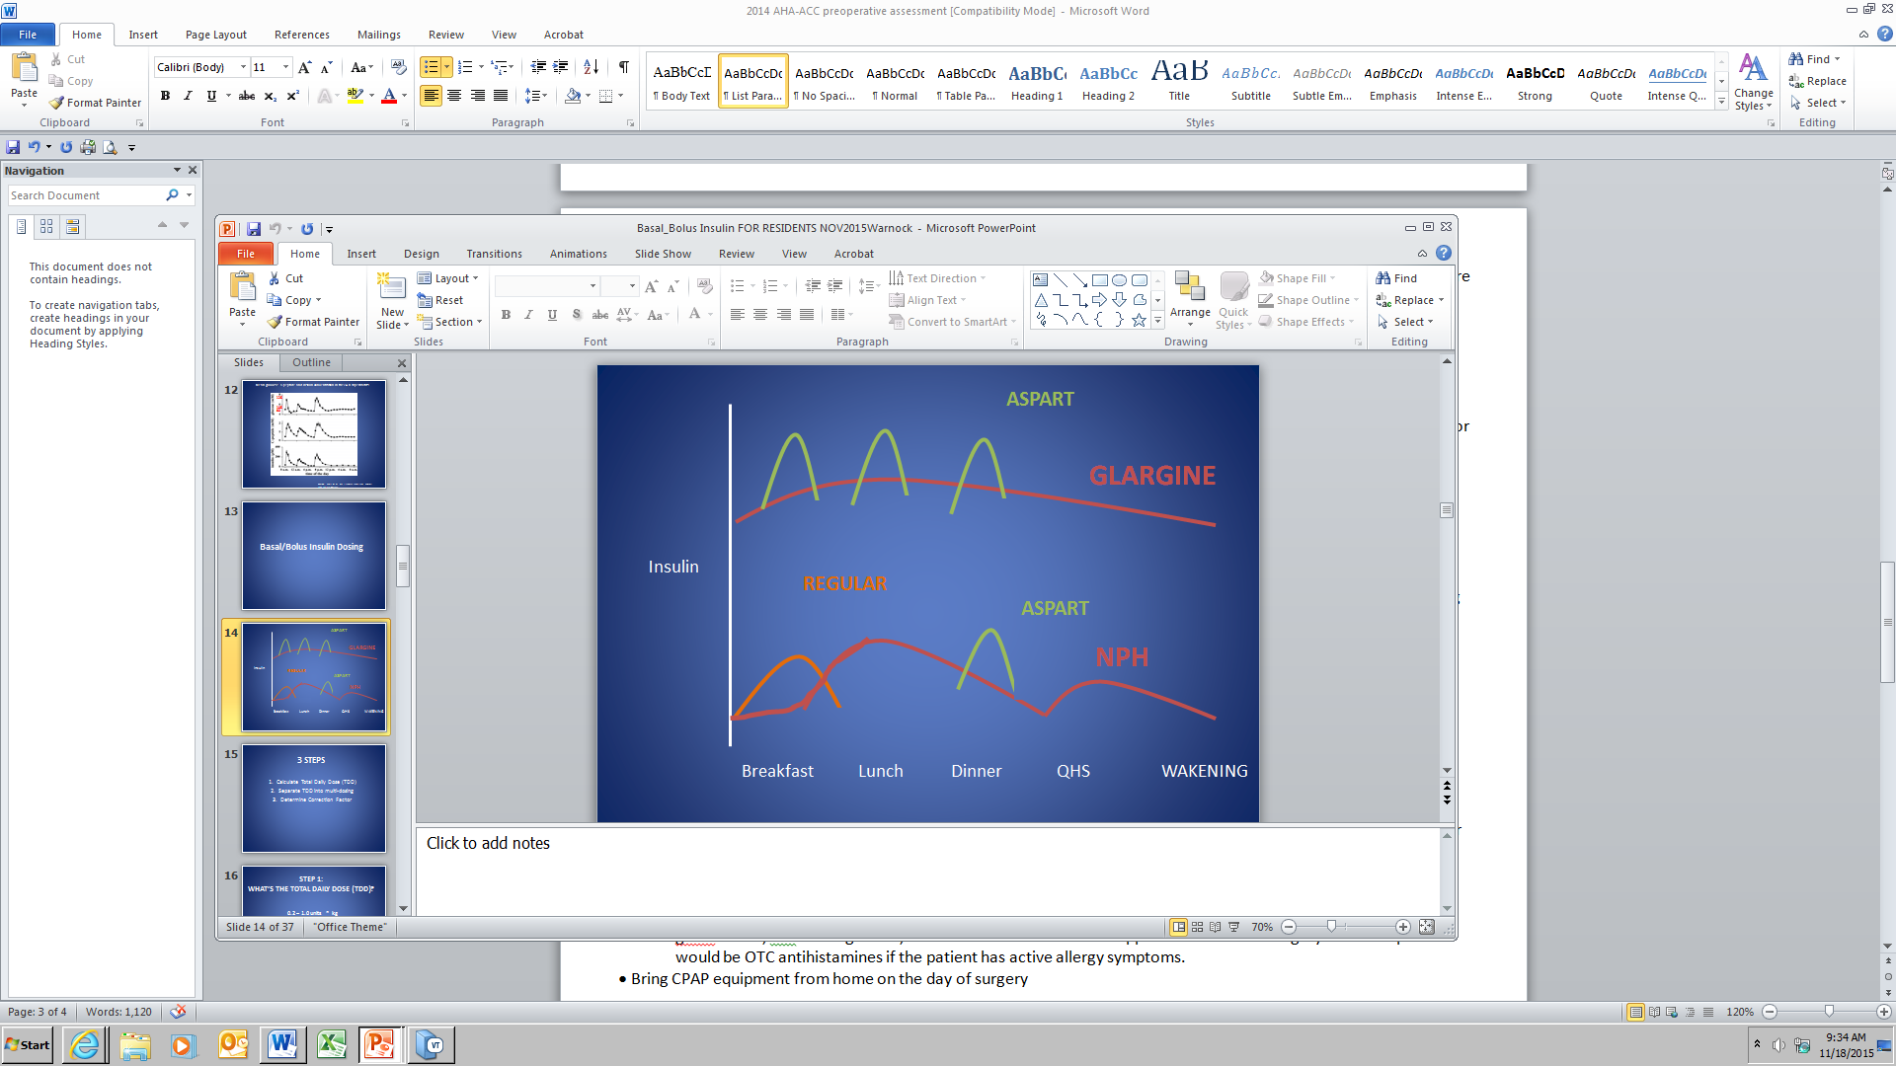

*NPH is useful as a basal insulin to cover prednisone- induced insulin resistance.*

*Glargine is usually the preferred basal insulin. It achieves more predictable steady state levels than NPH.*

slide from Dr Alicia Warnock, Endocrinology

* Inpatient Insulin regimen, Step 1: Calculate proposed total daily dose of insulin (or use the patient’s current total daily dose):
  + Weight (kg) x 0.2 to 1 units/kg = total daily dosing
  + Which value for units/kg depends on age, renal function, patient’s sensitivity to insulin

Calculating insulin sensitivity:

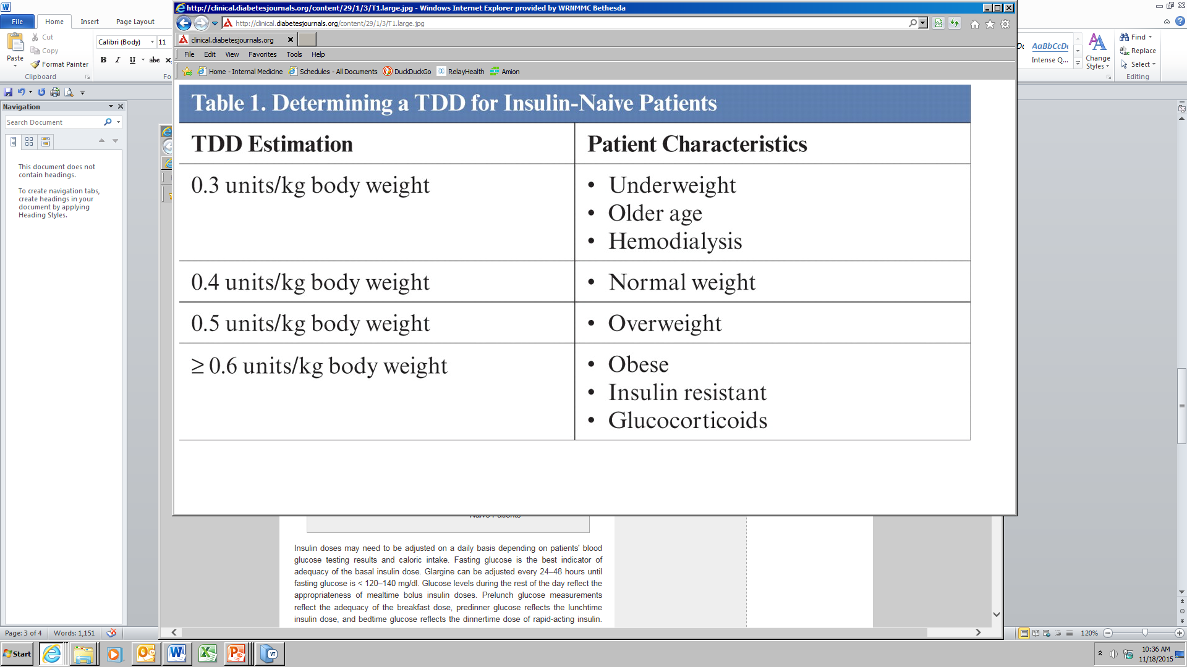

Reference: Clinical Diabetes **January 2011** vol. 29 no. 1 **3-9**

* Step 2: Split the total daily dose into a basal (long acting) dose plus 3 ac doses (note: assuming that the patient is eating and has glargine as the basal insulin)
  + - * 1. 50% of the dose is basal insulin (glargine – or NPH but half life of NPH varies from person to person more than glargine)
        2. 50% of the dose is prandial insulin, split into three before meal doses. Note: if patient is not eating complete meals, it may be necessary to decrease the amount of short acting bolus accordingly.
* Step 3: Calculate the correction factor: How much additional rapid-acting insulin needed to achieve blood glucose goal? 1800/*Total daily dose* = correction factor. This gives you the increment in glucose readings at which you increase the amount of correction rapid acting (aspart)\* insulin by one unit. For example, for a total daily dose of 20 units, the correction factor is 90.

**STEROIDS**

* Consider likelihood of HPA axis suppression and type and duration of surgery
* Studies show HPA axis suppression can take up to 1 year to fully recover
* **Nonsuppressed HPA axis**: Continue same glucocorticoid regimen for all of the following (and no needed HPA axis eval)
  + GC less than 3 weeks (any dose)
  + AM prednisone less than 5 mg for any duration
  + less than prednisone 10 mg every other day
* **Suppressed HPA axis**: need additional glucocorticoids in perioperiative period; see below regimens
  + Prednisone 20 mg or more per day for 3 weeks or greater
  + Patients with Cushingoid appearance
* **Intermediate/Unknown HPA axis**: either should undergo testing (morning cortisol before 8AM) or receive empiric glucocorticoid coverage esp if urgent/emergent surgery
  + Patients taking GC in a dose equivalent to [prednisone](http://www.uptodate.com/contents/prednisone-drug-information?source=see_link) 5 to 20 mg daily for more than three weeks
  + 3 or greater intra articular steroid injection within 3 months prior to surgery
  + 3 or greater spinal glucocorticoid injection within 3 months prior to surgery
  + greater than or equal to 750 mcg fluticasone for more than 3 weeks prior to surgery
  + greater than or equal to 2 g/day high potency topical steroids for more than 3 weeks prior to surgery
* **Stress Dose Regimens**:
  + Minor procedures/ local anesthesia- take usual morning dose
  + Moderatesurgical stress: (joint replacement): take usual morning dose then 50 mg hydrocortisone IV just before procedure and 25 mg hydrocortisone q 8 hours x 24 hours.
  + Majorsurgical stress: (open heart surgery, gastrectomy): take usual morning dose then 100 mg IV hydrocortisone before anesthesia induction and 50 mg q 8 hours x 24 hours.

**OTC MEDICATIONS** – Get an accurate list! May affect coagulation and platelet function, and have other pharmacodynamic and pharmacokinetic effects. In the absence of an adequate data base of clinical trials evaluating outcomes, it is recommended that such supplements be held for at least one week preoperatively. There is no evidence that surgery should be delayed if this is not feasible.

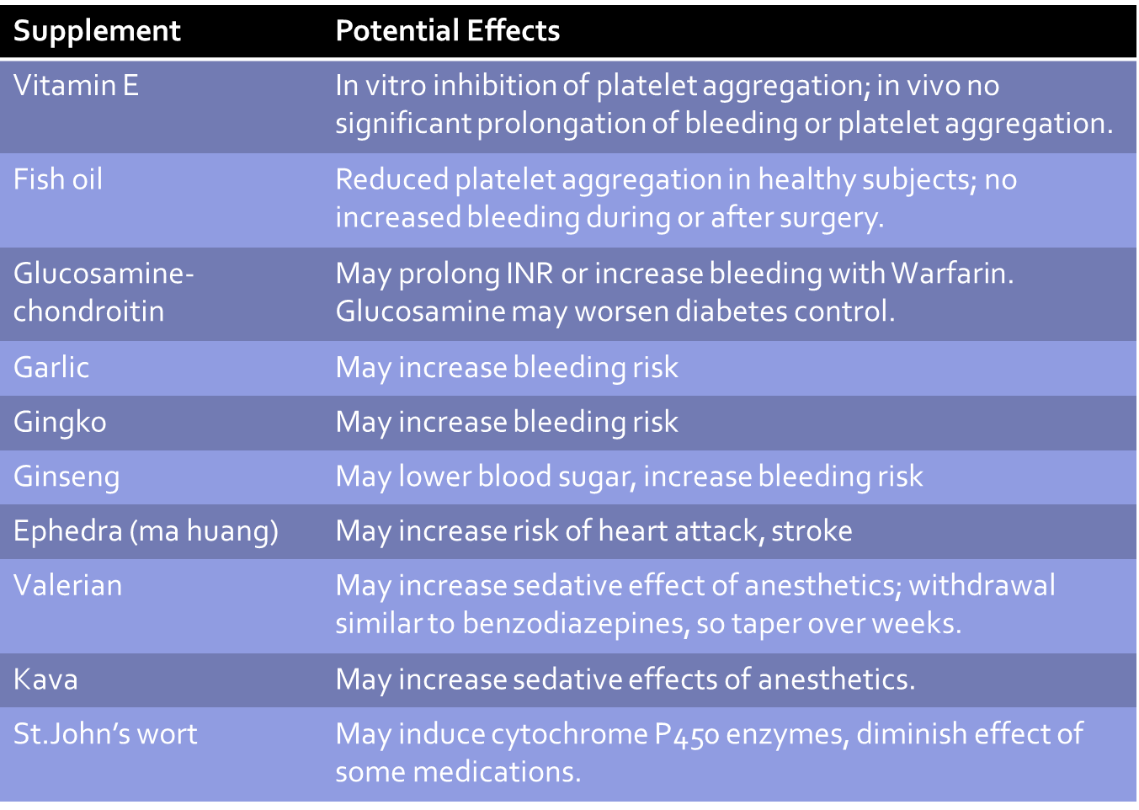

**COPD/ASTHMA INHALERS –** use all inhalers day of surgery! Check for wheezing with forced expiration. Suggest albuterol order prn cough, wheezing or shortness of breath.

**NEURO MEDS**

AEDS – continue perioperatively;

* Most AED are available in IV route (if prolonged NPO, ie miss more than 2 doses of usual AED); if not, consider lorazepam

**PSYCH MEDS**

* SSRIs –discontinuing if on high dose could lead to withdrawal symptoms; some increased risk of bleeding esp when used with NSAIDS or AC
* TCAs – could incr the action of indirect-acting sympathomimetics (ephedrine). No reported cases of arrhythmias
* Benzos – discontinuing could lead to withdrawal and seizures. Chronic use may incr anesthetic requirements
* MAOis
  + drug interactions:
    - Excitatory: serotonin syndrome, elev BP
    - Depressive: inhibit liver enz and cause narcotic accumulation and sedation
  + Discontinuation NOT recommended, since their use is usually for refractory depression, and could precipitate an exacerbation of MDD
  + Instead, anesthesia should avoid meperidine, and use only direct-acting sympathomimetics
* Antipsychotics: safe, multiple routes available if patient NPO
* Mood stabilizers: their use may be an indication of more resistance illness and hence an increased potential for recurrence of illness if med stopped

**RHEUM meds**

* **Non-Biologic DMARDs**: Continue Methorexate (MTX), Leflunomide (Arava), Hydroxychloroquine (Plaquenil), Sulfasalazine (SSZ) throughout perioperative period
* **Biologic DMARDs**: withhold medicine and plan surgery at end of dosing cycle.

Examples:

* Etanercept (usual once per week dosing): schedule surgery in second week after first withheld dose
* Adalimumab (every 2 week dosing): schedule surgery in third week after first withheld dose
* Abatacept (IV once per month): schedule surgery in 5th week after first withheld dose
* Rituximab (every 6 months): schedule surgery in month 7 after first withheld dose

\*\* do not restart until external wound healing is complete (around 2 weeks post op)

* **Kinase Inhibitors -** Tofacitinib (daily oral dosing): withhold 1 week prior to surgery
* **Lupus (SLE) medications:** Mycophenylate Mofetil (Cellcept), Azathioprine (Imuran), Cyclosporine, Tacrolimus (FK506). Decision to withhold made on individual basis. Consider holding 7 days prior to surgery in patients with mild to moderate lupus. For patients with severe SLE and multiorgan involvement 🡪 continue.

**ANTIPLATELET MEDS**

* Primary Prevention – can almost always safely discontinue antiplatelet agent. Should the patient be on antiplatelet in the first place??
* Secondary prevention with stents –see below slide
* Timing of interruption of antiplatelet therapy
  + At very least, try to continue aspirin through perioperative period
  + If discontinued, use the following time periods
  + Aspirin – discontinue 5-7 days before surgery
  + Clopidogrel – discontinue 5 days before surgery
  + Prasugrel – discontinue 7 days before surgery
  + Ticagralor – discontinue 3 days before surgery
  + Restart 24-48 hours after surgery depending on bleeding risk

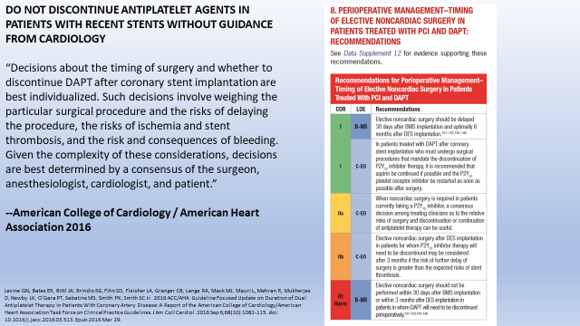

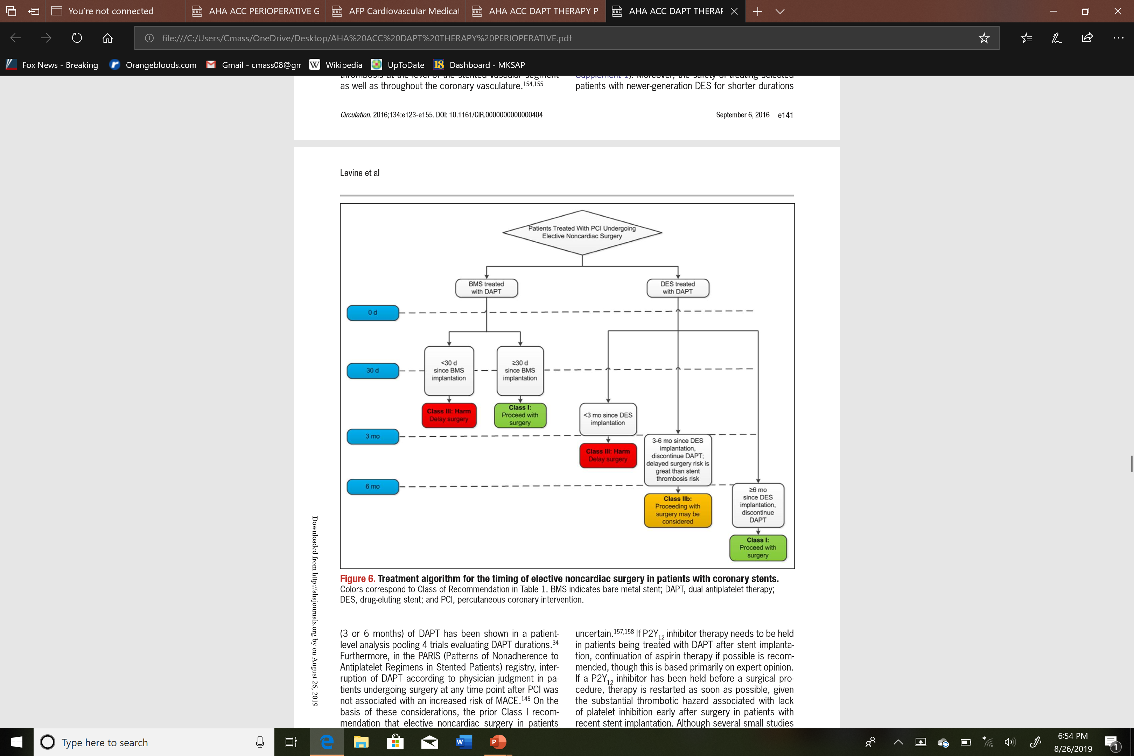

**ANTICOAGULATION**

Start by assessing the following:

|  |  |  |  |
| --- | --- | --- | --- |
| **Risk stratum** | **Indication for anticoagulant therapy** | | |
| **Mechanical heart valve** | **Atrial fibrillation** | **VTE** |
| **Very high thrombotic risk\*** | Any mitral valve prosthesis  Any caged-ball or tilting disc aortic valve prosthesis  Recent (within six months) stroke or transient ischemic attack | CHA2DS2-VASc score of ≥6  (or CHADS2 score of 5-6)  Recent (within three months) stroke or transient ischemic attack  Rheumatic valvular heart disease | Recent (within three months) VTE  Severe thrombophilia (eg, deficiency of protein C, protein S, or antithrombin; antiphospholipid antibodies; multiple abnormalities) |
| **High thrombotic risk** | Bileaflet aortic valve prosthesis and one or more of the of following risk factors: atrial fibrillation, prior stroke or transient ischemic attack, hypertension, diabetes, congestive heart failure, age >75 years | CHA2DS2-VASc score of 4-5 or CHADS2 score of 3-4 | VTE within the past 3 to 12 months  Nonsevere thrombophilia (eg, heterozygous factor V Leiden or prothrombin gene mutation)  Recurrent VTE  Active cancer (treated within six months or palliative) |
| **Moderate thrombotic risk** | Bileaflet aortic valve prosthesis without atrial fibrillation and no other risk factors for stroke | CHA2DS2-VASc score of 2-3 or CHADS2 score of 0-2 (assuming no prior stroke or transient ischemic attack) | VTE >12 months previous and no other risk factors |

1. **Estimate thromboembolic risk**

* Very High to High thromboembolic risk patients 🡪should try to limit period without AC, maybe bridging?
  + Examples:
    - Delay elective surgery for…
      * Ischemic stroke within last month
      * Afib pt with poor AC use within last month
    - Can NOT delay surgery
      * Stop AC as close to surgery as possible and resuming ASAP after surgery; consider bridging and/or Temp IVC filter
* Moderate thromboembolic riskpatients 🡪 often stop AC w/o bridging

1. **Estimate bleeding risk** – often can continue AC perioperative if low bleeding risk procedure and TE risk is very high to high

|  |  |
| --- | --- |
| **High bleeding risk procedure (two-day risk of major bleed 2 to 4%)** | **Low bleeding risk procedure (two-day risk of major bleed 0 to 2%)** |
| Any major operation od duration >45min | Abdominal hernia repair |
| AAA repair | Abdominal hysterectomy & Dilatation and curettage |
| CABG, Heart Valve replacement | Arthroscopic surgery lasting <45 minutes |
| Endoscopically guided fine-needle aspiration | Axillary LN dissection |
| Foot/hand/shoulder surgery | Bronchoscopy with or without biopsy |
| Hip and knee replacements | Carpal Tunnel repair |
| Kidney Biopsy | Cataract and noncataract eye surgery |
| Laminectomy | Cholecystectomy; Hemorrhoidal surgery |
| Neurosurgical/urologic/head and neck/abdominal/breast cancer surgery | Cutaneous and bladder/prostate/thyroid/breast/lymph node biopsies |
| Polypectomy, variceal treatment, biliary sphincterectomy, pneumatic dilatation | Gastrointestinal endoscopy ± biopsy, enteroscopy, biliary/pancreatic stent without sphincterotomy, endosonography without fine-needle aspiration |
| Transurethral prostate resection | Hydrocele repair |
| Vascular and general surgery | Pacemaker and cardiac defibrillator insertion and electrophysiologic testing |

**\*\*\*\*This website can help you determine what to do and how to assess TE risk vs bleeding risk**

[**http://thrombosiscanada.ca/tools/?calc=perioperativeAnticoagulantAlgorithm**](http://thrombosiscanada.ca/tools/?calc=perioperativeAnticoagulantAlgorithm)

<http://tools.acc.org/ManageAnticoag/#!/content/manager/>

1. **Determine timing of AC interruption**
   * **WARFARIN** - half life 36-42 hours
     + Stopping BEFORE surgery
       - Stop 5 days prior to surgery
       - Check INR day before surgery (if possible)
         * If >1.5 give low dose Vit K (1-2mg) prior to surgery
         * If ≤ 1.4 proceed with surgery
     + If bridging….typically for very high or high TE risk
       - Therapeutic dose SQ LMWH or unfractionated heparin started 3 days before surgery
       - Resume regular dose warfarin 12-24hours post-op; takes 5-10 days to reach INR 2.0; bridge until then
   * **DOACs**

* Dabigatran, Rivaroxaban, Apixaban, Endoxban - stop 2-3 days before (or 2-4 days before if CrCl 30-50)
* Typically don’t have to bridge given rapid offset/onset
* May bridge if post-op pts can’t take meds po (ie, intestinal ileus)
* Resume post-op when hemostasis has been achieved (ie, 1 day after low bleeding risk surgery and 2-3 days after high bleeding risk surgery
* For neuroaxial procedures, high risk for possible castotrophic spinal or epidural hematoma so… stop dabigatran for 4 to 5 days prior and factor Xa inhibitors 3 to 5 days

1. **Determine whether to use bridging**

* Bridge patient taking **warfarin** with…
  + Stroke or embolic event w/in 3 months
  + Mechanical mitral valve
  + Mechanical aortic valve + other risk factor(s) (Afib, prior VTE, LVEF <30, hypercoagulable condition, or more than one mechanical valve )
  + Afib with HIGH stroke risk (CHADS2 score 5-6, stroke/systemic embolism w/in 3 months, concomitant rheumatic valvular heart disease with mitral stenosis)
  + VTE w/in 3 months
  + Recent PCI w/in 3 months
  + Prior VTE during chronic AC interruption
* Bridging is generally not used for **DOACs**. However, bridging may be appropriate for individuals on these agents who have a very high thromboembolic risk and a more prolonged interruption of their anticoagulant (eg, due to postoperative intestinal ileus that prevents oral intake)
* For patients 3-12 months after acute VTE
  + No pre-op bridging
  + Post-op use DVT proph AC (ie, Lovenox 40mg SQ daily)

**Timing of Heparin Bridging**

* Start 3 days before surgery (2 days after stopping warfarin)
* LMW Heparin - d/c 24 hours before surgery
  + Lovenox hold the evening before surgery dose
  + Dalteparin give ½ the dose the day before surgery
* Unfractionated Heparin – stop IV fusion 4-5 hours before surgery
* Post-op, resume bridging 24-72 hours post-op pending hemostasis and severity of bleeding risk
  + Remember typically restart warfarin on same day heparin is restarted
* Neuraxial (ie, spinal or epidural) anesthesia should not be used in anticoagulated individuals, due to the risk of potentially catastrophic bleeding into the epidural space.

**2017 ACC periprocedural mgmt. of AC w/ NVAF recommendations are a little different. See below charts.**

classified the most commonly performed procedures into 4 bleeding risk levels: 1) no clinically important bleed risk; 2) low procedural bleed risk; 3) uncertain procedural bleed risk; or 4) intermediate/high procedural bleed risk

<http://jaccjacc.acc.org/Clinical_Document/PMAC_Online_Appendix.pdf>

